ITD – ITIN Power Apps Training · Student Lab Guide
Lab 00: Environment and Data Setup
Management Workforce Availability App — “My Team Availability”
Estimated time | 30–45 minutes
Difficulty | Beginner — no prior Power Apps experience required
You will need | A web browser (Microsoft Edge or Chrome) and your training account sign-in
Before you start | Have your instructor confirm your assigned Power Apps environment name and your SharePoint training site URL

Lab Overview
In this lab you will prepare everything the rest of the labs depend on: you will sign in to your training environment, learn your way around the Power Apps maker portal, and create the data source that will store workforce availability records. By the end of this lab you will have a working list of columns and a handful of sample (fictitious) records ready to connect to an app in Lab 01.

Objectives
- Access your Power Apps personal developer / training environment.
- Create the workforce availability data source.
- Review the app scenario, the people who will use it, and the sample data.
- Verify that only sanitized, fictitious data is used — never real employee (HCM) data.
ℹ NOTE
This training uses only fictitious data (for example, names like “Alex Rivera” and emails ending in @example.test). Never type real employee names, real email addresses, or real leave/HR data into this training environment.

About the App You Will Build
Across Labs 00–08 you will build “My Team Availability” — a mobile-friendly Canvas App that gives managers a consolidated view of team availability: who is in the office, working from home, on leave, on mission, attending training, or otherwise unavailable. The app supports team coverage and workload planning while teaching you the foundational building blocks of Power Apps.

Part A — Sign In and Find Your Environment
Power Apps is entirely browser-based — there is nothing to install. Follow the steps below exactly, in order.
- Open your web browser and go to the address bar.

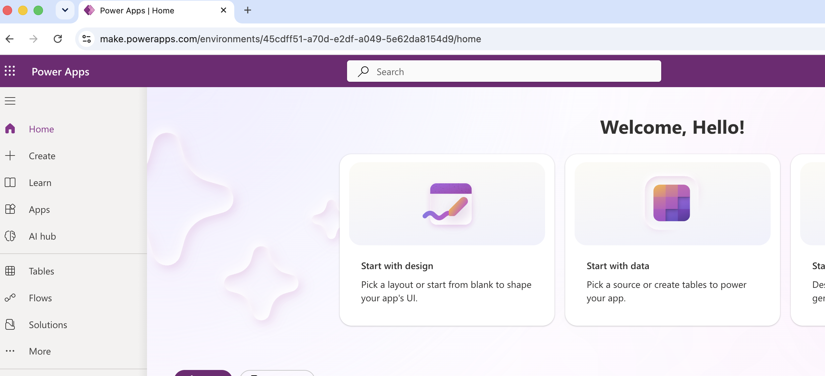
Type this address and press Enter: https://make.powerapps.com
- Sign in using your training account email and password when prompted. If you are already signed in to Microsoft 365, this screen may be skipped automatically.
- Locate the environment selector in the top-right corner of the page. It is a small button showing an environment name (for example, “Contoso (default)”) next to a gear/settings icon.
→ This tells you which “workspace” you are currently working in. Everything you build only exists inside the selected environment.
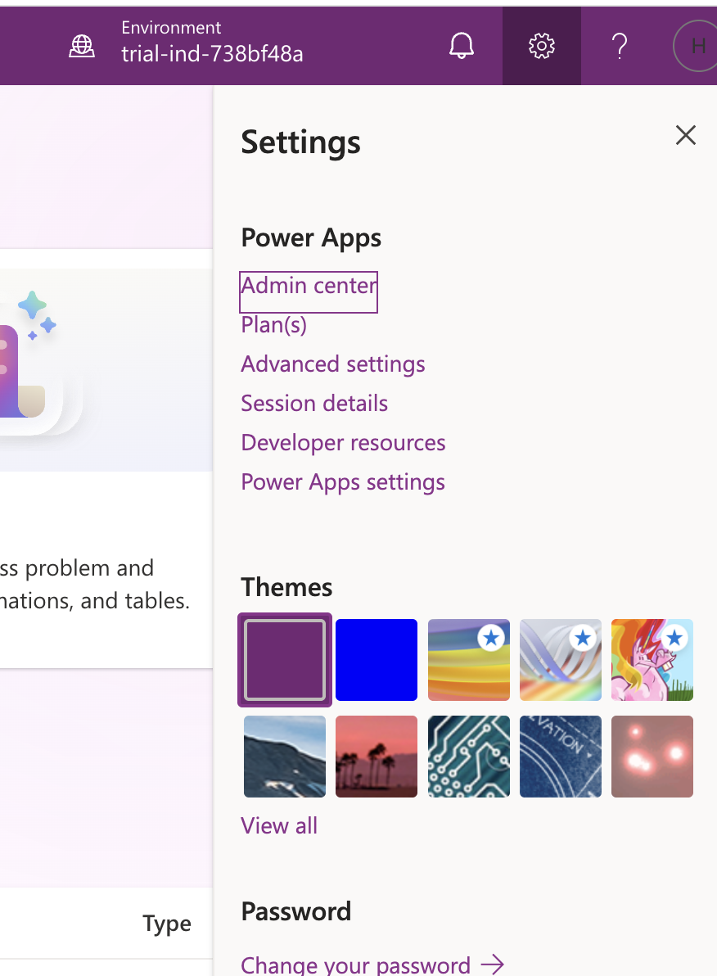
- Click the environment selector to open the environment list, then select the environment your instructor assigned to you (for example, “ADB Power Apps – Training”).
- Confirm you landed on the Home page — the left-hand navigation bar should be visible with items such as Home, Apps, Create, Tables, and Flows, and the environment name in the top-right should now match the one your instructor gave you.
💡 TIP
If you ever feel “lost” in Power Apps, look at the top-right corner first. The environment name shown there is the single most common reason things “disappear” — apps and data only show up inside the environment they were created in.

Quick Tour — The Left Navigation Bar
Menu item | What it's for
Home | Landing page with recent apps and quick-start tiles
Create | Start a new app, flow, or table — you will use this in Lab 01
Apps | A list of every app you have created or been shared
Tables | Dataverse tables, if your environment uses Dataverse
Flows | Power Automate flows — used later in Lab 07

Part B — Review the Data Model
Before creating anything, review the fields (columns) your data source needs. You will create exactly these columns in Part C. Keep this table open in a second tab or print it — you will refer back to it.
Field | Type | Sample value
Record ID | Number / auto-generated | 1001
Employee Name | Person or single line of text | Alex Rivera
Employee Email | Single line of text | alex.rivera@example.test
Manager Email | Single line of text | manager@example.test
Team or Unit | Choice or single line of text | HCM Applications
Work Date | Date | 23 September 2026
Availability Status | Choice | Working from Home
Start Time | Time (optional) | 9:00 AM
End Time | Time (optional) | 5:00 PM
Location | Single line of text (optional) | Remote
Coverage Notes | Multiple lines of text (optional) | Available through Teams
Backup Contact | Person or text (optional) | Jamie Cruz
Notification Required | Yes/No | Yes
Submitted By | Person or text | Alex Rivera
Last Updated | Date and time | Training timestamp

Availability Status values
When you create the Availability Status choice column in Part C, add exactly these six choices, in this order:
- 1. In Office
- 2. Working from Home
- 3. On Leave
- 4. On Mission
- 5. Attending Training
- 6. Other Approved Unavailability

Part C — Create the Data Source (SharePoint List)
You will create a SharePoint list named WorkforceAvailability. A SharePoint list is a simple, no-license-required way to store structured data, and it connects to Power Apps in one click. If your instructor has told you to use Dataverse or Excel instead, follow their alternate instructions for this part only — the column names and types below still apply.

Step 1: Open your SharePoint training site
- Open a new browser tab and go to the SharePoint site URL your instructor provided (for example, https://yourorg.sharepoint.com/sites/PowerAppsTraining).
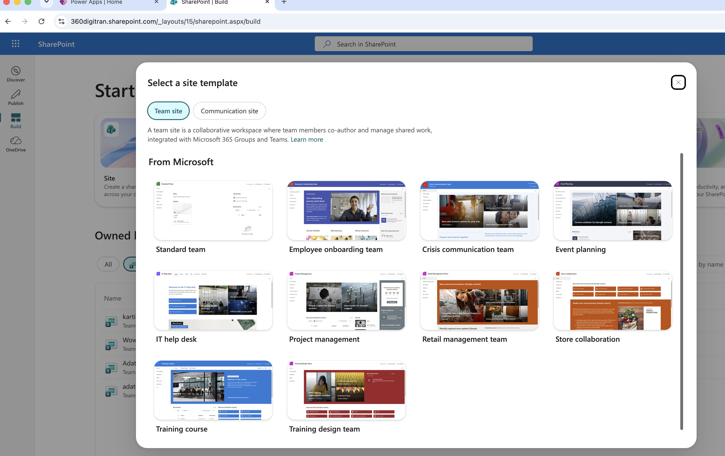
- Sign in with the same training account if prompted.

Step 2: Create the list
- On the site's Home page, click “+ New” near the top-left of the page, just under the site name.
- From the dropdown menu, select “List.”
- On the “Create a list” screen, click the “Blank list” tile.
- In the Name box, type
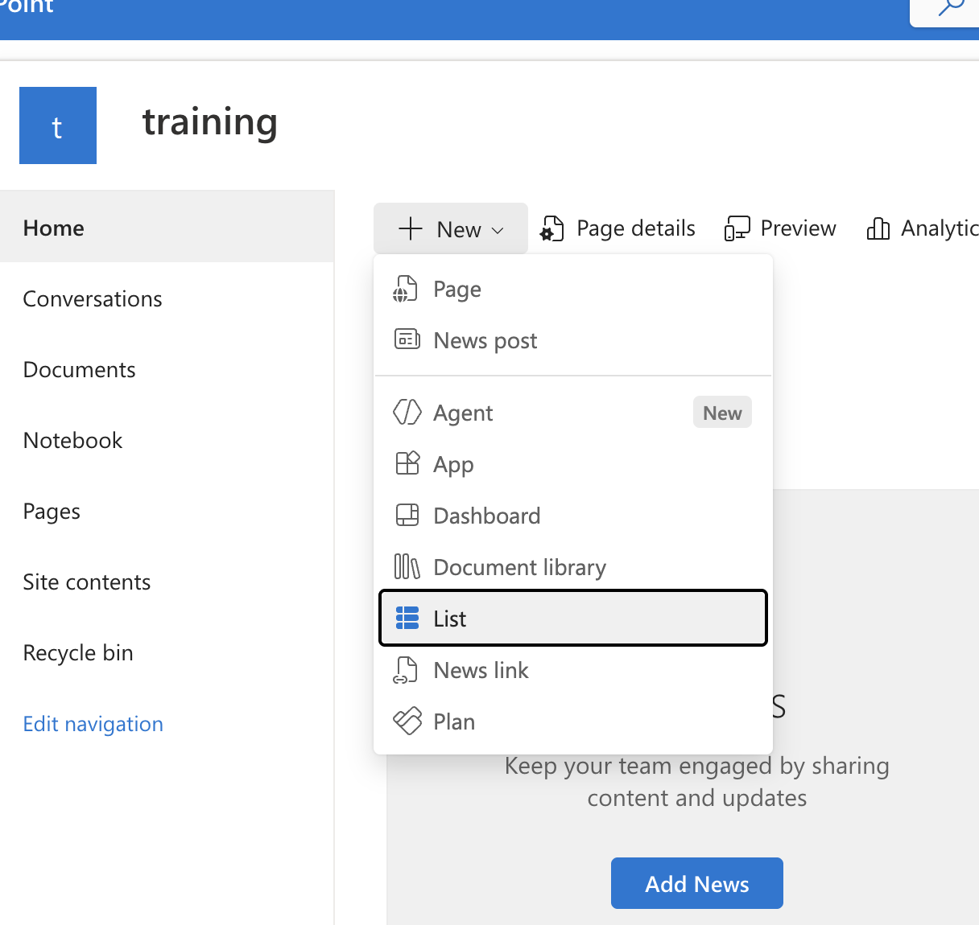
Name: WorkforceAvailability (one word, no spaces — this becomes the technical name Power Apps will use).
- Leave “Show in site navigation” turned on so you can find the list again later.
- Click “Create” in the bottom-right corner. SharePoint will open your new, empty list — it currently only has a default “Title” column.
💡 TIP
You will reuse the built-in “Title” column as your Record ID or rename it to “EmployeeName” — either works for training. The steps below assume you keep Title as-is and add all other fields as new columns.

Step 3: Add the columns
You will repeat the same four-click pattern for every column in the data model table above (except Employee Name, which can reuse the built-in Title column). Do this once carefully, then repeat.
- At the top of the list, click “+ Add column.”
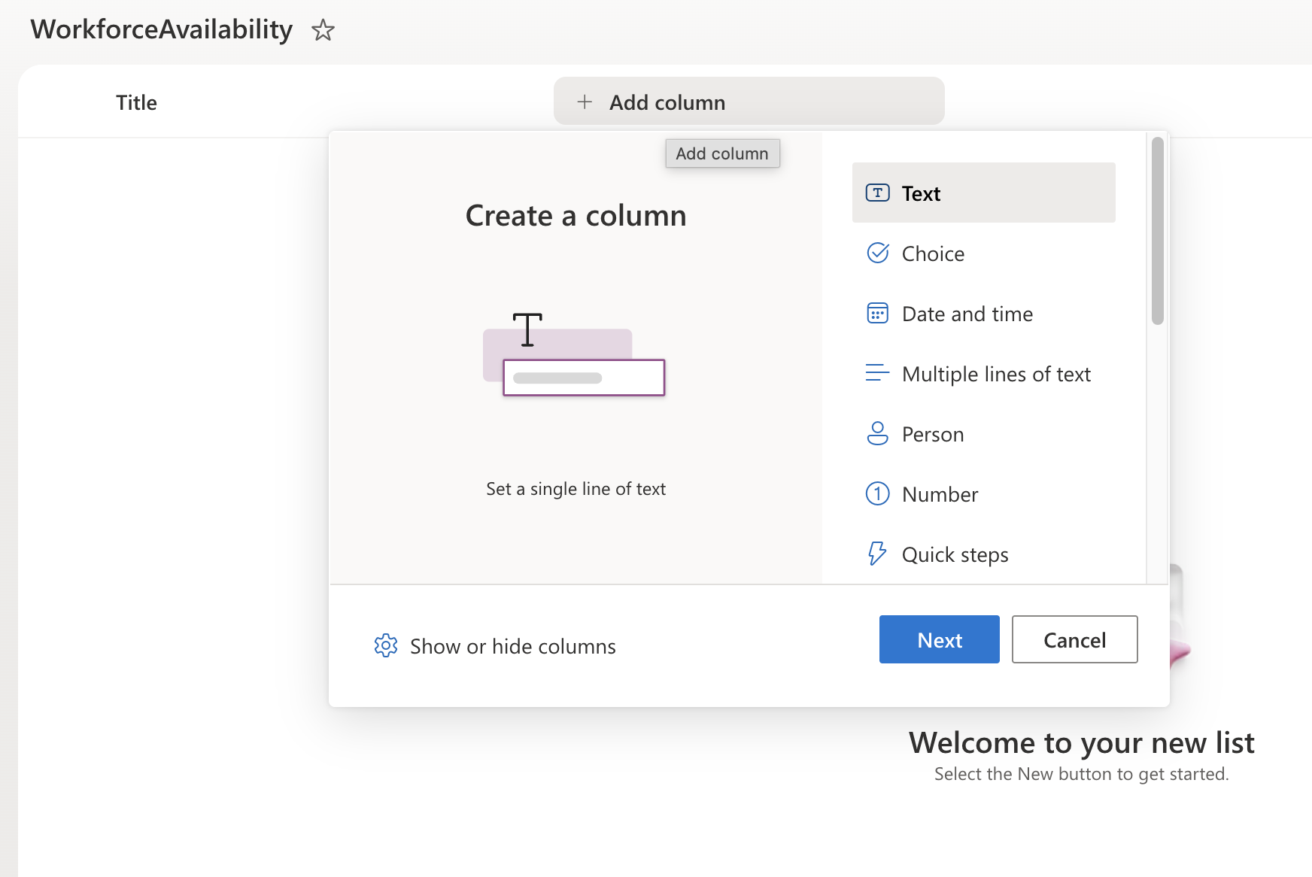
- Choose the column type that matches the Type listed in the data model table (for example, choose “Single line of text,” “Choice,” “Date,” “Yes/No,” or “Date and time”).
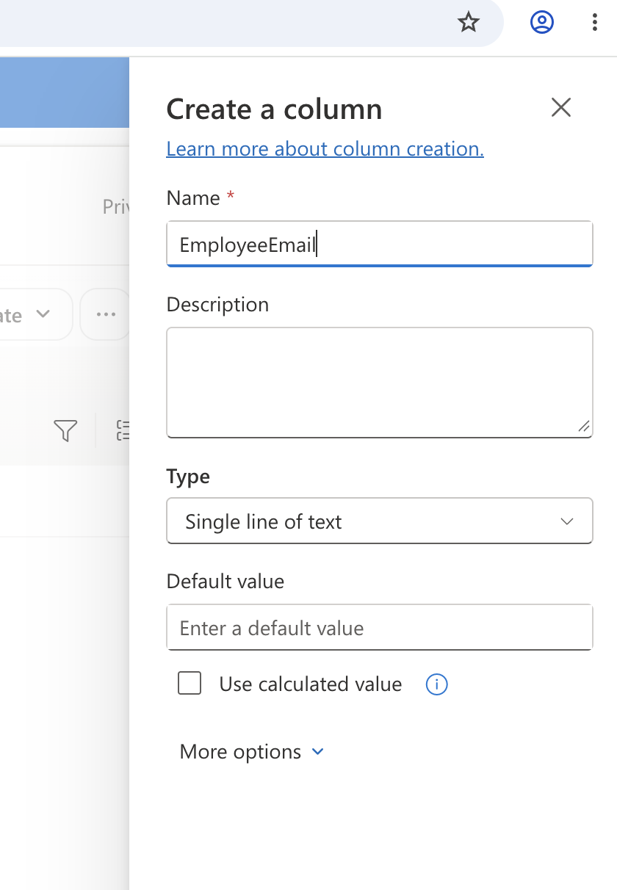
- Type the column Name exactly as shown below (no spaces) so it matches the formulas used in later labs.
- For Choice columns, type each choice value on its own line in the “Type each choice on a new line” box.
- Click “Save.” Repeat for each remaining column.

Use these exact internal names (no spaces)

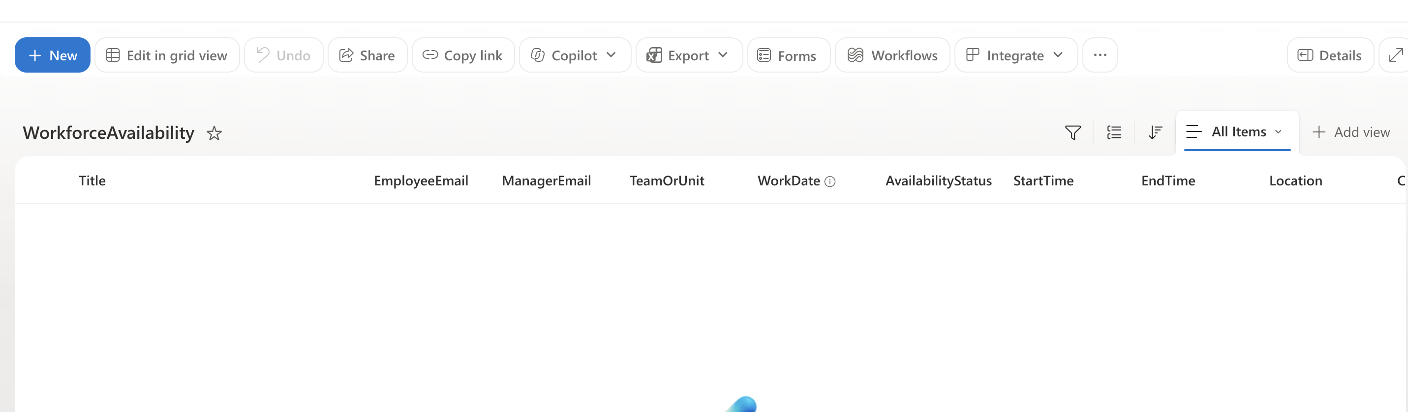 when you add each column:
Column name to type |  | Column type to choose | Choice values (if applicable)
EmployeeEmail |  | Single line of text | —
ManagerEmail |  | Single line of text | —
TeamOrUnit |  | Single line of text | —
WorkDate |  | Date | —
AvailabilityStatus |  | Choice | In Office / Working from Home / On Leave / On Mission / Attending Training / Other Approved Unavailability
StartTime |  | Single line of text (optional) | —
EndTime |  | Single line of text (optional) | —
Location |  | Single line of text (optional) | —
CoverageNotes |  | Multiple lines of text (optional) | —
BackupContact |  | Single line of text (optional) | —
NotificationRequired |  | Yes/No | —
SubmittedBy |  | Single line of text | —
ℹ NOTE
Skipping the optional columns is fine if you are short on time — you can always add them later the same way. The required columns for Lab 03's form are Work Date, Availability Status, Team or Unit, and Manager Email, so make sure those four are created.

Part D — Add Sample (Fictitious) Records
Add the following

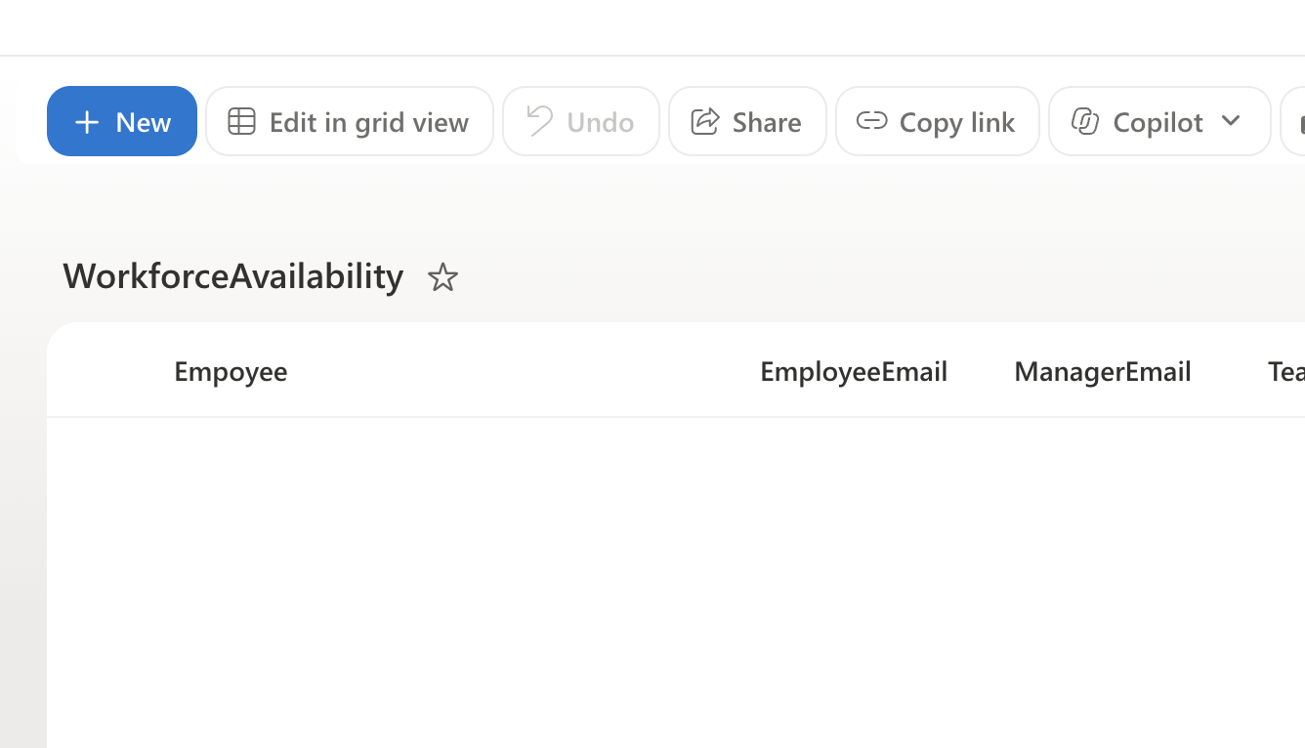

Rename Title as Employee
five fictitious records so that every participant in the class is comparing the same results in later labs. To add a record, open your list and click “+ New” above the column headers,

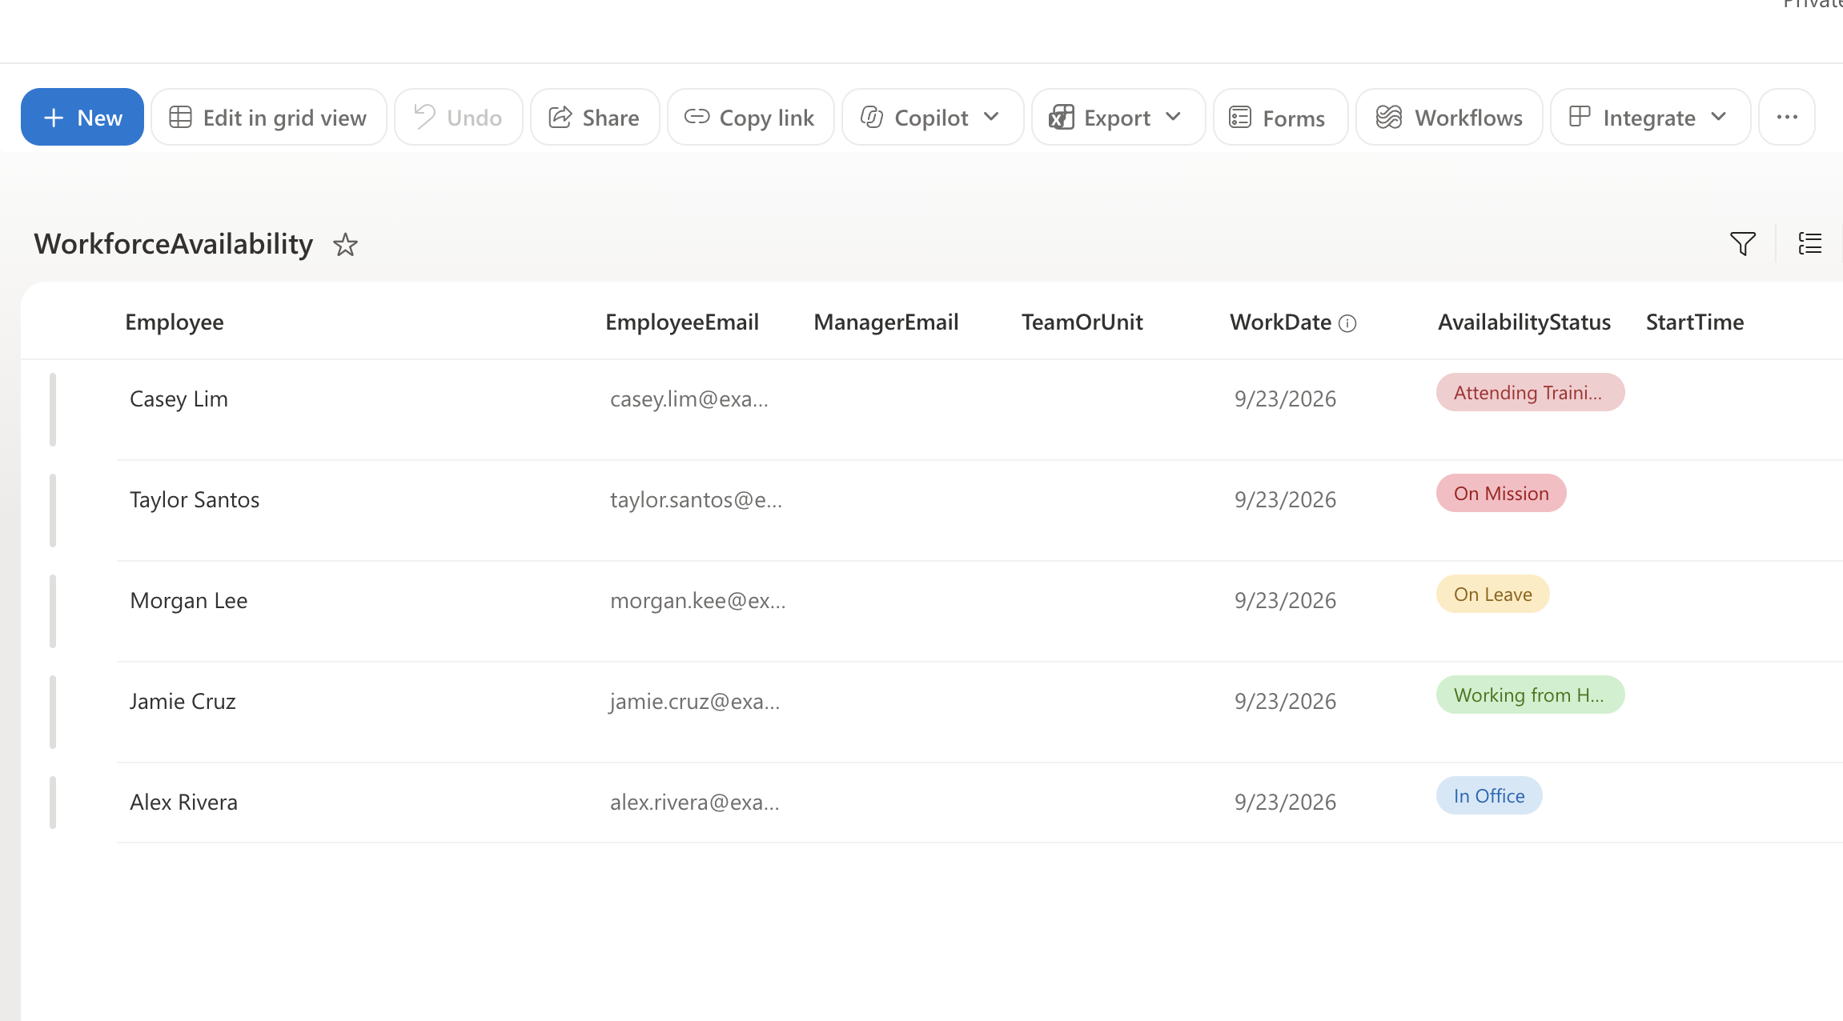 fill in the fields shown below, then click “Save.” Repeat for all five rows.
Employee | Email | Work date | Status | Location | Coverage notes
Alex Rivera | alex.rivera@example.test | 23 Sep 2026 | In Office | ADB HQ | Available
Jamie Cruz | jamie.cruz@example.test | 23 Sep 2026 | Working from Home | Remote | Available through Teams
Morgan Lee | morgan.lee@example.test | 23 Sep 2026 | On Leave | — | Backup contact assigned
Taylor Santos | taylor.santos@example.test | 23 Sep 2026 | On Mission | Field location | Limited availability
Casey Lim | casey.lim@example.test | 23 Sep 2026 | Attending Training | Training room | Unavailable during session

For Manager Email, use manager@example.test for every row so that Labs 04–06 (which filter by manager) return results for everyone in class.

Part E — Data Privacy Checklist
Before you move on, confirm all of the following:
- Every email address ends in @example.test (never a real work or personal email).
- Every employee name is fictitious (use the sample names provided, or invent similarly obviously-fake names).
- No real leave dates, medical information, or HR data has been entered anywhere in the list.
- The SharePoint list is only shared with your training class, not the wider organization.
⚠ IMPORTANT
If you are unsure whether something counts as sensitive HCM data, leave it out and ask your instructor. This training environment must never contain real personnel data.

Lab 00 Complete — Checkpoint
✅ CHECKPOINT
You should now have: (1) confirmed access to your assigned Power Apps environment, (2) a SharePoint list named WorkforceAvailability with the columns from Part C, and (3) five fictitious sample records from Part D. In Lab 01 you will create the Canvas App and, in Lab 02, connect it to this exact list.

Next: Lab 01 — Create the My Team Availability App

